!!! WORK IN PROGRESS !!!



Version 9.0.0
Version 9.0.0 | 16/05/2011
Modified tables |  | Created tables | Modified index
??? |  | ??? | ???

Fillings display mode: The key GlassDrawingAsSeen from [System] section of settings table allow to draw or not the fillings as seen or as fabricated.

[System]
GlassDrawingAsSeen = 0 filling is drawn as fabricated (real dimension) = 1 filling is drawn as seen

Sides sequence: The standard WinPro label for a given side would not be relevant for some cases, due to new shapes now available.
Indeed, the user may now create shapes composed of several bottom left sides for a same frame, that is why the current labelling of sides is outdated for such designs.
Sides will be easier to handle using instead a numbering sequence, clockwise, starting at « 0 ».
The side number « 0 » is the one with the slope the nearest from 180°, but always lower than 180°.
For instance into a rectangle, the bottom side has an angle of 180°, the left one 90°, the top is 0° and the right is 270°.
The first side lower than 180° is then the left side.
The SideIndex variable returns the current side number.

New function GetArraySize ():This function is available anywhere at data set up level, and returns the number of cells from an array variable, global or local.

Example :

NbFill := GetArraySize (_FillType) returns into variable NbFill the number of cells of the global array variable _FillType

Enhancement of connection type variables: La When a user previously modified the connection type by rules through variables Assembly1 or Assembly2, this had no consequence onto the design created, this was for information only.
You may now modify those variables by rules and see consequences straight onto the drawing of the design, as well as into computation from Components tab.

Example :

Assembly1 := StraightShort modifies assembly join from the concerned frame and side
New function Slope (X0, Y0, X1, Y1): L The slope function returns the angle between a horizontal line and the {X0, Y0 ; X1, Y1} segment of the side currently computed. For a horizontal top side (where {X0, Y0} is on the left), slope woth « 0 ».
The reference axis is a horizontal line traced from left to right (axis X), the angle value is given anticlockwise.

Example :

If Side = Top
a := Slope (X0, Y0, X1, Y1) renvoie returns into a variable the top side angle
End If

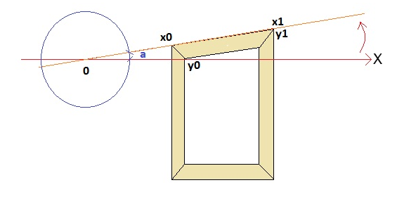

Overview

WinPro version 9.0.0 introduces a complete rebuild of the shapes computation system, allowing users to compute, draw and produce shaped designs difficult or impossible to set up until now.
This rebuild of the shape engine has involved the creation of a new set of functions and variables making complex shapes easier to implement.
Existing variables and functions from previous versions are still available, meaning that existing data set up are fully compatible with version 9.
The particular cases of incompatibility (variable name changes, behaviour changes, …) will be detailled into the following and next release note, when required.
Those functions and variables are available at any data set up level for a window code. Either they are initialized by WinPro according shape information input (global shape and dimension, outer frame or sash frame sections, …), and may then be loaded and used into data set up, or they are freely defined by user.
The shapes handled may be closed or opened, simple or complex, but are always composed of straight or curved segments.
In order to be trained to use this new concept of set up, this manual will be laid with a complete sample of data set up using the new shape features. The miscellaneous function sets will also be listed at the end of the document.

Set up of an oblic transom through a composed panel

1 - Introduction

This set up is designed to input horizontal oblic transom from a WinPro’s composed panel.
The aim is here to define and compute components for such a panel feature (profiles, articles, glazings and drawings).
For the below oblic transom, we need to compute outer frame profile also, but mainly beads, transom profile and glazings that will be input and compute from the composed panel.

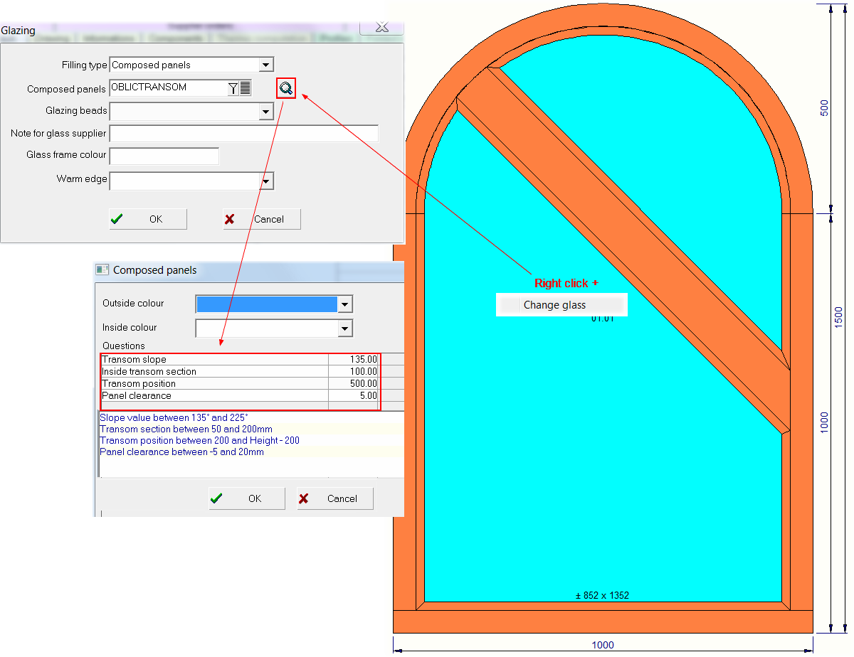

Finally we should obtain a bill of material …
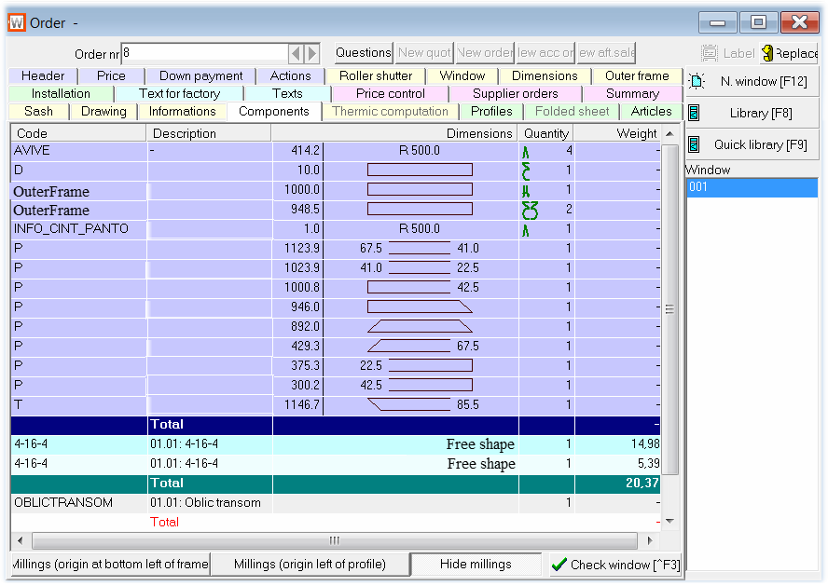

… glazings included !
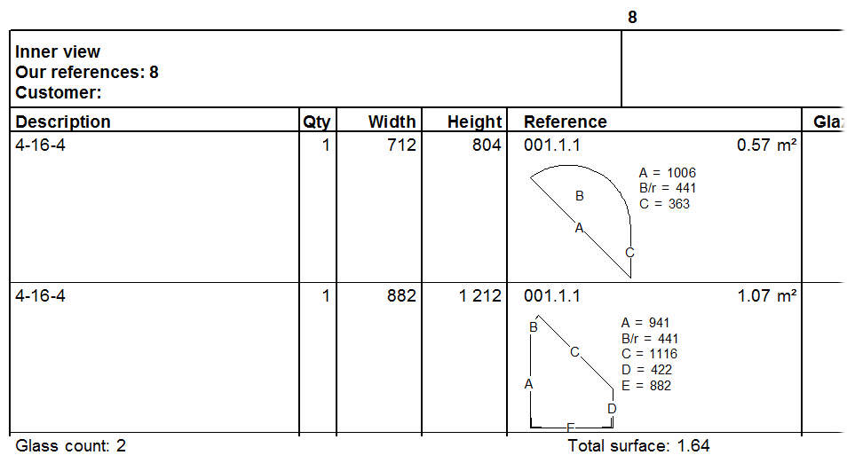
2 – Composed panel setup : questions

The implied composed panel for the set up of the oblic transom example will be set with a list of questions into the appropriate tab.
4 questions to control the oblic transom feature :
- Transom slope (Format : Numeric | Variable name : QCP_Slope) : Slope angle of the oblic transom, starting from the right side of the filling where the panel is used. The reference line crosses the horizontal line through the transom position (voir ci-dessous), starting from the right side. La valeur est comprise entre 135° (horizontale) et 225° (forcée par paramétrage).
- Inside transom section (Format : Numeric | Variable name : QCP_Section) : Oblic transom section (correspond to SmallerHeight variable, meaning inside section excluding beads). Value is set between 50 & 200mm (forced by rule).

- Transom position (Format : Numeric | Variable name : QCP_Position) : Oblic transom position, from the filling right side, outside edge of the frame. Value between 200 & Height - 200mm (forced by rule).
- Panel clearance (Format : Numeric | Variable name : QCP_Clearance) : Panel clearance. This will affect glazings computation mainly. Value between -5 & 20mm (forced by rule).

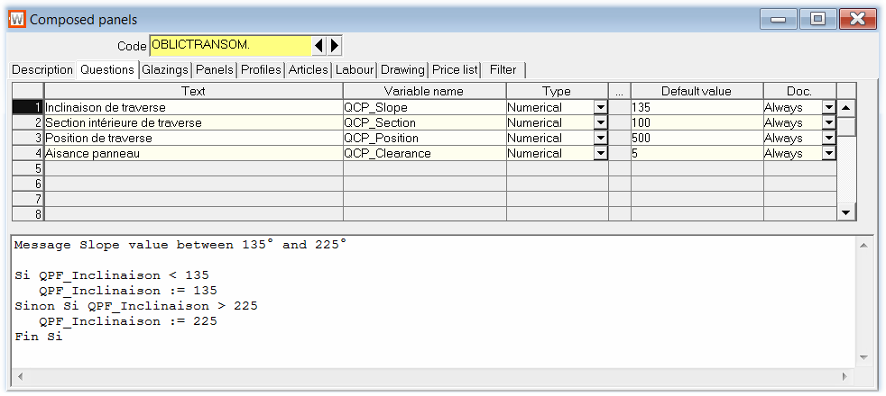

2 – Composed panel set up : prerequired computation, Glazings tab

The bigger part of the required computation will be done at this stage tu be used into following tabs, including glazing or panel consumation, profiles, articles and drawings.

STEP 1 : Prerequired computations
Below is the code used into the first FORMULA page of the Glazings tab. You may follow easier this training documentation by copying and pasting this code into a composed panel formula, removing comments if needed :

# Temporary variable that will store the global shape of the panel
TmpPanelGlobShapeNum := 0

# This code fetches the outside shape of the panel, and stores it into
# the first available cell of the Shape array (see Basic notions).
# Refer to chapter about WinPro creation and modification functions for shapes
# for more details on instruction LoadShape ().
# See List of predefined shapes variables for details about variable _FillingShapeNum,
# paragraph related to shapes from fillings.
# Result 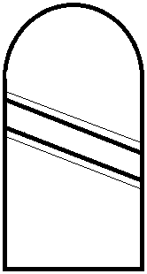

LoadShape (- 1, _ FillingShapeNum,, FillingIndex)

# Memorize the index of created shape into working variable
# See Basic notions for the array LastCreatedShapeNum [], chapter about target shapes.
TmpPanelGlobShapeNum := LastCreatedShapeNum [1]

# Debug (enable this line in case of need)
# This instruction allows to control values computed by WinPro for shape of index
# TmpPanelGlobShapeNum. See
# WinPro creation and handling functions for shapes of boards, 1 setting variant.
# For debug purpose only.
# GestShapeInfo (TmpPanelGlobShapeNum)

# Temporary variables for sub shapes Left and Right when sit on cutting line
# (reference line), the left correspond to the bottom, and right correspond to top shape
# into the example, because the slope is ranged between 90 & 270°, from left to right.
TmpLeftPanelShapeNum:= 0
TmpRightPanelShapeNum:= 0

# Step 1: sub shapes generation
# The panel global shape TmpPanelGlobShapeNum is cut into 2 sub shapes.
# Both shapes are stored into the first available cells of the shape array (… -1, -1 …).
# The global shape of the panel TmpPanelGlobShapeNum is cut following a line of
# angle defined by question « Transom slope» (variable QCP_Slope).
# The X coordinate of the line correspond to the filling width
# (…,_FillX [FillingIndex] + _FillWidth [FillingIndex], …).
# The Y coordinate of the line correspond to the value of question « Transom position »
# (variable QCP_Position), cumulated to Y coordinate of the filling
# (…,_FillY [FillingIndex] + QCP_Position, …).
# The cutting line is offset of a demi transom inside section toward the bottom,
# , corresponding to question « Transom section » (- QCP_Section / 2).
# See WinPro creation and modification functions for shapes.
CutShape (TmpPanelGlobShapeNum, - 1, - 1, QCP_Slope, _FillX [FillingIndex] + _FillWidth [FillingIndex], _FillY [FillingIndex] + QPF_Position, - QPF_Section / 2, 0)

# Storage of the index of both generated sub shape into temporary variables.
# Result :
# TmpLeftPanelShapeNum = 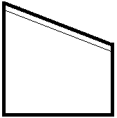
# TmpRightPanelShapeNum = 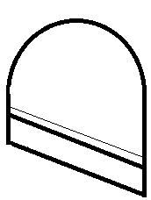
TmpLeftPanelShapeNum := LastCreatedShapeNum [1]
TmpRightPanelShapeNum := LastCreatedShapeNum [2]

# Copy of the left (bottom) shape corresponding to final panel rebate value, clearance excluded and beads included.
CopyShape (TmpLeftPanelShapeNum, - 1)
# Storage of shape number for final bottom panel into a dedicated variable
CutLeftPanelShapeNum:= LastCreatedShapeNum [1]

# Temporary variables for sub shapes from right panel (top, )
# This top shape is cut again to generate the final top shape,
# (beads included, clearance excluded), and the shape of the transom at the bottom
TmpTransomPanelShapeNum := 0
TmpFinalRightPanelShapeNum := 0

# Step 1: sub shapes generation
CutShape (TmpRightPanelShapeNum, - 1, - 1, QCP_Slope, _FillX [FillingIndex] + _FillWidth [FillingIndex], _FillY [FillingIndex] + QCP_Position, + QCP_Section / 2, 0)

# Storage of shape number for generated sub shapes into dedicated variables.
# Result :
# TmpTransomPanelShapeNum = 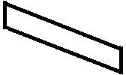. INSIDE section of transom beads excluded.
# TmpFinalRightPanelShapeNum = 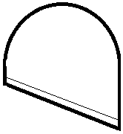.
TmpTransomPanelShapeNum := LastCreatedShapeNum [1]
TmpFinalRightPanelShapeNum := LastCreatedShapeNum [2]

# Copy of the left shape (bottom) corresponding to the transom. ATTENTION the section
# set here is considered inside and not overall outside ! Beads are then not included !
# This values are not kept, used for fillings computation.
CopyShape (TmpTransomPanelShapeNum, - 1)

# Storage of shape index for the transom inside section (left/bottom) into a variable.
CutTransomPanelShapeNum := LastCreatedShapeNum [1]

# An additionnal cut onto the global shape should be done for the transom as it is defined
# from inside section and not overall outside section as required, this in order to correctly
# compute glazings dimensions.

# Temporary variables for sub shapes, final transom computation, including rebate (20mm).
# 2 successive cuts needed from the global shape.
BeadableDepth := 20
TmpFinalTransomPanelShapeNum := 0
CutFinalTransomPanelShapeNum := 0

# Step 1: sub shapes generation for final transom
# Same cut as previously except that beadable depth is included this time
# (offset = - QCP_Section / 2 – BeadableDepth).
CutShape (TmpPanelGlobShapeNum, - 1, - 1, QCP_Slope, _FillX [FillingIndex] + _FillWidth [FillingIndex], _FillY [FillingIndex] + QCP_Position, - QCP_Section / 2 - BeadableDepth, 0)

# Storage of sub shapes indexes into variables, only the right (top) shape will be kept
# and cut again afterward.
# This shape corresponds to Global panel shape – Bottom shape underneath outside
# transom shape.
# Result :
# TmpFinalTransomPanelShapeNum = 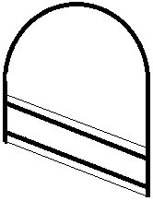.
TmpFinalTransomPanelShapeNum := LastCreatedShapeNum [2]

# Step 2: second cut onto the top remaining panel shape to obtain the transom.
CutShape (TmpFinalTransomPanelShapeNum, - 1, - 1, QCP_Slope, _FillX [FillingIndex] + _FillWidth [FillingIndex], _FillY [FillingIndex] + QCP_Position, QCP_Section / 2 + BeadableDepth, 0)

# Storage of sub shapes indexes into variables, only the left (bottom) is kept at index 1
# (first created), corresponding to the transom
# Result :
# CutFinalTransomPanelShapeNum = 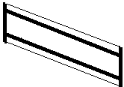
CutFinalTransomPanelShapeNum:= LastCreatedShapeNum [1]

# ######################################
# Final transom ready for cutting and drawing
# ######################################

# Copy of the right shape (top) corresponding to final panel beads included without clearance.
# .
CopyShape (TmpFinalRightPanelShapeNum, - 1)

# Storage of shape index for top final panel into variable.
CutFinalRightPanelShapeNum:= LastCreatedShapeNum [1]

# Shape computation for beads, left/bottom and right/top fillings.
TmpLeftBeadShapeNum := 0
TmpRightBeadShapeNum := 0

# Copy of left (bottom) shape corresponding to the shape to bead at the bottom,
# clearance not deducted.
# .
CopyShape (TmpLeftPanelShapeNum, - 1)

# Storage of the shape index to bead at the bottom into a variable
TmpLeftBeadShapeNum := LastCreatedShapeNum [1]

# Copy of right (top) shape corresponding to the shape to bead on top,
# clearance not deducted.
# .
CopyShape (TmpFinalRightPanelShapeNum, - 1)

# Storage of shape index for top beads into a variable.
TmpRightBeadShapeNum := LastCreatedShapeNum [1]

# Cutting variables for sub shapes of beads profiles, for the whole bead frame, top and
# bottom fillings.
# Array variable for cutting angles, as set into ShapeSubSideInfo 20/24 when
# GetShapeInfo with 14 settings is called.
CutBeadGlobalShapeNum : 0
CutBeadGlobalShapeNum := 0
Angle1BeadGlobalShapeNum : 0
Angle1BeadGlobalShapeNum := 0
Angle2BeadGlobalShapeNum : 0
Angle2BeadGlobalShapeNum := 0

# Profiles computation for left (bottom) shape.
# Extraction of global shape infos (here to know the number of sides).
# See WinPro creation and modification functions for shapes of boards for details
# about function GetShapeInfo ().
GetShapeInfo (TmpLeftBeadShapeNum,,,)

# Buffer variable for number of sides.
# See WinPro creation and modification functions for shapes of boards about value
# ShapeInfo ().
TmpBottomBeadNbSide := ShapeInfo [2]

# Extraction of global shape settings (here to know the number of sides).
i := 0
# loop onto all sides of the frame to bead
Repeat While i < TmpBottomBeadNbSide
# Extraction of shape info by side/sub side.
# Refer to WinPro creation and modification functions for shapes of boards for
# detail about function GetShapeInfo ()

GetShapeInfo (TmpLeftBeadShapeNum,, i, 0,,,, - 1, 0, 0, 20, 20, 20, 20)
# Loop onto all sub sides of the current side
# See chapter WinPro creation and modification functions for shapes of boards
# about value ShapeSideInfo ()

j := 1
Repeat While j <= ShapeSideInfo [1]
# Dynamic resize for the array of profiles shapes and angles, one cell is
# added to current size.
CutBeadGlobalShapeNum : GetArraySize (CutBeadGlobalShapeNum) + 1
Angle1BeadGlobalShapeNum : GetArraySize (Angle1BeadGlobalShapeNum) + 1
Angle2BeadGlobalShapeNum : GetArraySize (Angle2BeadGlobalShapeNum) + 1
# Values of the complete bead shape number, from the sub side of current
# side, will be stored into the last cell created.
# Index 4 is considered to obtain the complete shape (total profile length)
# of sub side 1 of current side.
# Index 8 is considered to obtain the complete shape (total profile length)
# of sub side 2 of current side.
# Index 4 + 4 * (sub side number - 1) (<=> 4 + (j-1)*4) is considered to obtain
# the complete shape (total profile length) of sub side j of current side (current side = i).
CutBeadGlobalShapeNum [GetArraySize (CutBeadGlobalShapeNum)] := LastCreatedShapeNum [4 + (j - 1) * 4]
# Angles values are stored into array variables.
# See WinPro creation and modification functions for shapes of boards
# about value ShapeSubSideInfo ()
Angle1BeadGlobalShapeNum [GetArraySize (Angle1BeadGlobalShapeNum)] := ShapeSubSideInfo [24]
Angle2BeadGlobalShapeNum [GetArraySize (Angle2BeadGlobalShapeNum)] := ShapeSubSideInfo [20]
j += 1
End Repeat
i += 1
End Repeat

# Profiles computation for left (top) shape. See upper comments.
GetShapeInfo (TmpRightBeadShapeNum,,,)
TmpTopBeadNbSide := ShapeInfo [2]
i := 0
Repeat While i < TmpTopBeadNbSide
GetShapeInfo (TmpRightBeadShapeNum,, i, 0,,,, - 1, 0, 0, 20, 20, 20, 20)
j := 1
Repeat While j <= ShapeSideInfo [1]
CutBeadGlobalShapeNum : GetArraySize (CutBeadGlobalShapeNum) + 1
Angle1BeadGlobalShapeNum : GetArraySize (Angle1BeadGlobalShapeNum) + 1
Angle2BeadGlobalShapeNum : GetArraySize (Angle2BeadGlobalShapeNum) + 1
CutBeadGlobalShapeNum [GetArraySize (CutBeadGlobalShapeNum)] := LastCreatedShapeNum [4 + (j - 1) * 4]
Angle1BeadGlobalShapeNum [GetArraySize (Angle1BeadGlobalShapeNum)] := ShapeSubSideInfo [24]
Angle1BeadGlobalShapeNum [GetArraySize (Angle1BeadGlobalShapeNum)] := ShapeSubSideInfo [20]
j += 1
End Repeat
i += 1
End Repeat

# Purge of the shape array, release cells from temporary variables.
# See chapter WinPro creation and modification functions for shapes for details
# about function DeleteShape ()
DeleteShape (TmpPanelGlobShapeNum)
DeleteShape (TmpLeftPanelShapeNum)
DeleteShape (TmpRightPanelShapeNum)
DeleteShape (TmpFinalRightPanelShapeNum)
DeleteShape (TmpTransomPanelShapeNum)
DeleteShape (TmpFinalTransomPanelShapeNum)
DeleteShape (TmpLeftBeadShapeNum)
DeleteShape (TmpRightBeadShapeNum)

STEP 2 : Glazings computation, Glazings tab
Main calculation is done previously, into next rules within Glazings tab, glass units may be consumed as follows :

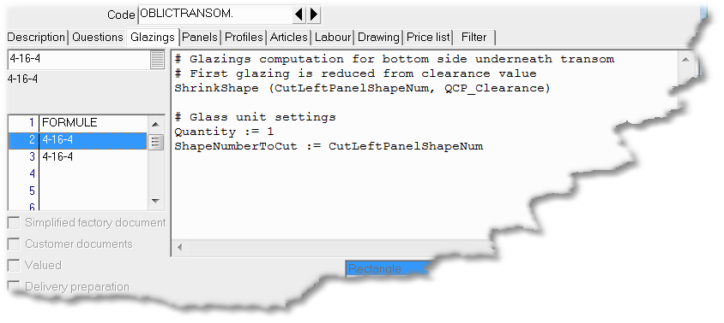
CutLeftPanelShapeNum = .

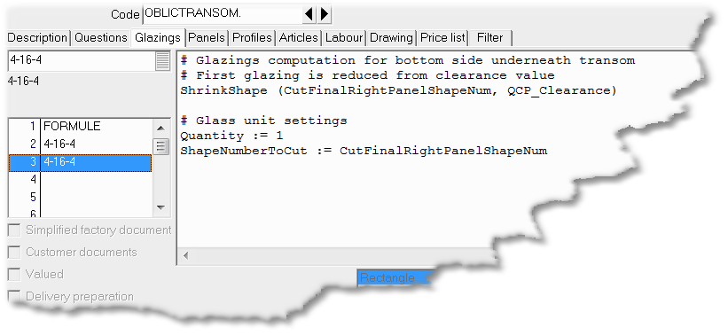
CutFinalRightPanelShapeNum = .

See WinPro creation and modification functions for shapes concerning function ShrinkShape ().
See WinPro functions for cutting shape for variable ShapeNumberToCut.

STEP 3 : Profiles cut for transom and beads, Profiles tab
Main calculation is done previously, into next rules within Profiles tab, profiles may be consumed.

Transom cutting rule
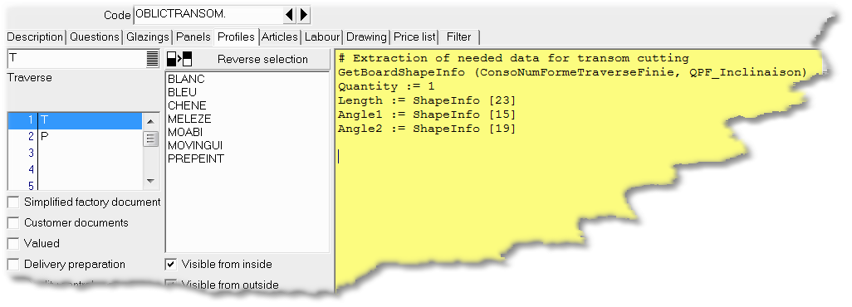

Beads cutting rule
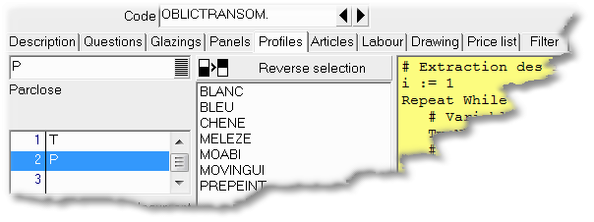

Code :

# Extraction of required data for cutting beads, loop on the whole profiles computed
# (top and bottom fillings)
i := 1
Repeat While i <= GetArraySize (CutBeadGlobalShapeNum)
# Counter for number of sides ("segment") for the current bead profile.
TmpBeadSideNum := 0
# Extract data of the BEAD shape !
GetShapeInfo (CutBeadGlobalShapeNum [i],,,)
# Stores the number of sides ("segment") of bead PROFILE itself.
TmpBeadSideNum := ShapeInfo [2]
# Loop onto sides of current profile, the aim is to retrieve the side (edge, segment) of the
# bead profile with label 2000=outside.
j := 0
Repeat While j < TmpBeadSideNum
# Extract information of profile shape by side (segment, edge) <=> variables
# ShapeInfo, ShapeSideInfo, ShapeSubSideInfo are filled.
GetShapeInfo (CutBeadGlobalShapeNum [i],, j, 0)
# Here we look for the side (edge, segment) of the bead profile with label 2000=outside
# (<=> WinPro length).
If ShapeSubSideInfo [28] = 2000
# Profile cut
Quantity := 1
Length := ShapeSideInfo [5]
Angle1 := Angle1BeadGlobalShapeNum [i]
Angle2 := Angle2BeadGlobalShapeNum [i]
End If
j += 1
End Repeat
# The Apply function is run for all bead profiles except the last one (Apply is implicit
# for the last one, as an alternative to last expected instruction Quantity := 0)
If i < GetArraySize (CutBeadGlobalShapeNum)
Apply
End If
i += 1
End Repeat

STEP 4 : Drawings for profiles, transom and beads, Drawing tab
Main computation is already done at step 1, we may now draw what has been computed, beads, transom and glazings.

WinPro drawings
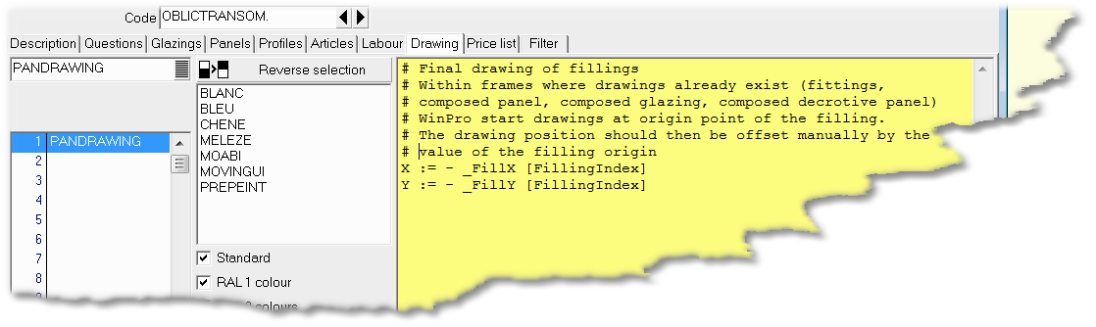

Code of drawing PANDRAWING:

PenColour (Black)
Brush (Colour, LightCyan)

# Drawing for first glazing computed, Bottom/Left
# See WinPro functions for cutting shape pour for details about DrawShape () function.
StartPath ()
DrawShape (CutLeftPanelShapeNum, 0, 0)
EndPath ()
FillAndBorderPath ()

# Drawing for second glazing computed, Top/Right
StartPath ()
DrawShape (CutFinalRightPanelShapeNum, 0, 0)
EndPath ()
FillAndBorderPath ()

# Drawing for transom, outer frame colour here
Brush (Colour, _OuterFrameIntColourRed, _OuterFrameIntColourGreen, _OuterFrameIntColourBlue)
StartPath ()
DrawShape (CutFinalTransomPanelShapeNum, 0, 0)
EndPath ()
FillAndBorderPath ()

# Drawing for beads, outer frame colour here
Brush (Colour, _OuterFrameIntColourRed, _OuterFrameIntColourGreen, _OuterFrameIntColourBlue)
i := 1
Repeat While i <= GetArraySize (CutBeadGlobalShapeNum)
StartPath ()
DrawShape (CutBeadGlobalShapeNum [i], 0, 0)
EndPath ()
FillAndBorderPath ()
i += 1
End Repeat

List of new variables and functions

Basic notions
In order to handle easier this new data set up concept for shapes computation, some reminders and additional vocabularies are detailed into this chapter.

Type of side

Sides are either simple or complex.
When simple, they may be straight or arched.
When complex, they are composed of « Sub - Sides » that are always simple.

Standard WinPro side feature

This is the usual WinPro side Top, Bottom, Left, Right, TopLeft, TopRight, BottomLeft and BottomRight. Usual label for each side is also assigned with a numeric value varying according the frame where the code is located.
Those sides are simple or complex.
The Side variable returns the name of the current side computed.

Segment

A segment is either straight or arched, that the smallest element of a shape.
Equivalent to the « Sub – Side » notion, but more generic.
For instance, a free shape within WpReport module may not have « side » nor « sub-side », but may be only composed of segments.

Sub-Side

A « Sub - Side » is either straight or arched, that is the smallest element of a shape.
A « Sub - Side » is a segment.
A « Sub - Side » always belongs to a side.

Shape array

The shape array is an array where the various shapes that will be computed may be stored and reuse when necessary. Into data set up it is possible to store 500 shapes into the array of shapes, from n°1 to n°500.
Into WpReport, it is possible to set a user defined array size. See function « CreerTableauForme () ».
Attention, a too big shape array will require memory when not necessary.

Target shape

Using any function returning a shape, the user may give the target shape number, or else set that winpro should store the shape into the first available cell of the array.
For the first case, the user just send the number of the shape to the function (or a variable containing the index). Take care anyway not to override an existing shape.
Variable « LastCreatedShapeNum » remains then unchanged.
For the second case, setting value « -1 » will imply Winpro to use the first cell(s) available.
Variable « LastCreatedShapeNum», that is an array variable, returns the index of the last shape(s) created. When the function used before the variable creates a single shape, only the first cell of the array variable is used, otherwise the program will use as many cells as shapes generated.

List of predefined shapes variables
Those shapes are generated by WinPro’s computation. They represent for example the shape of a frame, of a profile... They are not automatically loaded by WinPro to avoid a useless computation.
We then have to use a dedicated « LoadShape () » instruction to load a shape into memory. See chapter about functions for creating and modifying shape lower for more details about this function, its syntax and usage.
Below is the list of predefined shape variable available:

Shapes related to the outer frame

- _OutOuterFrameShapeNum
Shape variable for the outside edge of the outer frame. No additional setting required.

Example:

ChargerForme (- 1, _OutOuterFrameShapeNum) charge la forme extérieure du cadre dormant dans le premier emplacement disponible dans le tableau de forme.

- _InsOuterFrameShapeNum
Shape variable for the inside edge of the outer frame. No additional setting required.

- _ExtendedOuterFrameShapeNum
Shape variable for false arches.
The first setting correspond to the side number, the second one is unused.

Example:
LoadShape (- 1, _ExtendedOuterFrameShapeNum, SideIndex)

- _InputOuterFrameShapeNum
Shape variable for the outside edge of the outer frame, without considering the false arch, if there was no false arch. Pas d'arguments complémentaires. That’s the shape as input into Dimensions tab.

- _MasInputOuterFrameShapeNum
Shape variable for the outside edge of the outer frame, without considering the false arch, if there was no false arch. No additional setting required. That’s the shape as input into Dimensions tab, into masonery mode.

Shapes related to the sash frame

- _OutSashFrameShapeNum
Shape variable for outside edge of the sash frame currently computed. Attention, this is outside edge of sash frame and not of a single leaf.
No additional setting required.

- _OutSashFrameLeafShapeNum
Shape variable for outside edge of leaves from the sash frame currently computed, with a second setting used for the leaf index. Setting 1 remains unused here.

Example :

LoadShape (- 1, _OutSashFrameLeafShapeNum,, Leaf)

- _InsSashFrameLeafShapeNum
Shape variable for the inside edge of leaves from the sash frame, with a second setting for the leaf index. Setting 1 remains unused here.

Example :

LoadShape (- 1, _InsSashFrameLeafShapeNum,, Leaf)

- _SashFalseArchShapeNum
Shape variable for false arches.
The first setting is for the side index, the second for lkeaf index.

Example:

LoadShape (- 1, _SashFalseArchShapeNum, SideIndex, Leaf)

Shapes related to fittings frame

- _OutFittingsFrameLeafShapeNum
Shape variable corresponding to the outside of each leaf of a fittings frame for the current sash, the second setting is the leaf index. First setting remains unused.

Shapes related to transoms

- _OutTransomShapeNum
Shape variable for the outside edge of the current transom, the visible side of the transom viewed from outside.
No additional settings required.

- _InsTransomShapeNum
Shape variable for the inside edge of the current transom, the visible side of the transom viewed from inside without rebates (only smaller height is seen).
Pas d'arguments complémentaires.

- _TotTransomShapeNum
Shape variable for current transom, transom viewed from inside including rebates, the length is defined from the transom receiving it, without rebate. Or else, profile length before any join operation, or width of outside view with length of inside view.
No additional settings required.

Example:

LoadShape (- 1, _TotTransomShapeNum)

Shapes related to fillings

- _BeadsShapeNum
Variable for beads frame shape (without rebates).
The second setting is for the filling index.

Example:

LoadShape (- 1, _BeadsShapeNum,, FillingIndex)

- _FillingShapeNum
Variable for filling shape, clearance deduced.
The second setting is for the filling index.

Example:

LoadShape (- 1, _FillingShapeNum,, FillingIndex)

Label

For various functions, labels for sides of the shape may be used.
It is possible to use labels with following codes:
- 1000 = start
- 2000 = outside
- 3000 = end
- 4000 = inside
The following variables may also be used into data set up:
- Start = start
- Outside = outside
- End = end
- Inside = inside

WinPro creation and modification functions for shapes
Those functions are designed to create and hadle shapes from the shape array, as an extension of existing functions for such features into composed panels, as detailed into release note 6.4.24.

- LoadShape (Target shape number, Predefined shape code, Setting1, Setting2)

Function to load a shape defined within data set up. See previous chapter about predefined variables.
- Target shape number: Refer to basic notions.
- Predefined shape code : See list of variables of predefined shapes for current frame, for instance _OutOuterFrameShapeNum.
- Setting 1 and 2 : In function of shape to be loaded, several settings maybe needed, as leaf index. Refer to predefined shapes list for details.

Note :
When the function returns several shapes (e.g. list of false arch shapes), the target shape is automatically set to « -1 » value, corresponding to first available slots into shape array.

Example :

LoadShape (- 1, _FillingShapeNum,, FillingIndex)
Loads the global filling dimension clearance deduced, into the first available slot from the shape array. Refer to predefined shape variables for details about variable _FillingShapeNum.

- CreateShape (Index of shape to be created, Shape name [, Orientation], DimA, DimB, …, DimL)

2 versions of the instruction exists, this is the detail for standard version.
It allows to create free shapes (different from predefined) anywhere into the set up (Except WinPro drawings. Similar to shape handling functions into composed panels. See release note 6.4.24).
- Index of shape number to be created : Slot into the shape array, +1 for first available slot.
- Shape name : For instance Rectangle, Trapezium. See release note 6.4.24.
- Orientation : Shape orientation, according shape en fonction de la forme, Left or Right.
- DimA to DimL : Various dimensions to input for a given shape. See release note 6.4.24.

Example :

CreateShape (- 1, Rectangle, 1000, 1000)
This instruction loads a rectangle with dimensions 1000x1000 into the first available slot of the shape array.

- CreateShape (Shape nbr to be created, -77, trapezium number)

Creates trapezium shapes required from a computation of arches using functions BOWCUTxxx(). See release note 7.2.29.
- Shape nbr to be created: Slop within shape array, -1 for first available slot.
- -77 : Switch to allow fetching data from trapezium computation of a BOWCUTxxx () function.
- Trapezium number : Trapezium umber to copy as separate shape. Note that the first trapezium is indexed 0.

Example :

# Variables initialization
angleBD := 90
angleBF := 90
ray := 500
pX0 := 0
pY0 := 100
pX1 := 1000
pY1 := 100
ox := 500
oy := 100
pdx := 0
pdy := 0
pfx := 0
pfy := 0
ep := 80

# Initialization of computation for trapezium number into the bow (see release note 7.2.29)
a := BOWCUTInit ()
a := BOWCUTSetUsualWidths (50, 100, 150, 200, 250, 300, 400, 500, 800, 1000)
a := BOWCUTPenalty (2000)
a := BOWCUTDefineTmpBow (pX0, pY0, pX1, pY1, ox, oy, ray, ep, 0)
a := BOWCUTAddBow ()

# Trapezium number targeted set up (refer to release note 7.2.29)
tmpNumArc := 5
a := BOWCUTSetNbTrapeziums (tmpNumArc)

# Computation of trapezium sub shapes into the bow
i := 0
Repeat While i < tmpNumArc
CreateShape (110 + i, - 77, i)
i += 1
End Repeat

# Drawing set up :

PenColour (_OuterFrameIntLineColourRed, _OuterFrameIntLineColourGreen, _OuterFrameIntLineColourBlue)
Brush (Colour, Green)

Number (100, 50, tmpNumArc + 100)
i := 0

Repeat While i < tmpNumArc
StartPath ()
DrawShape (TmpNumForme + i, 0, 0)
EndPath ()
FillAndBorderPath ()
i += 1
End Repeat

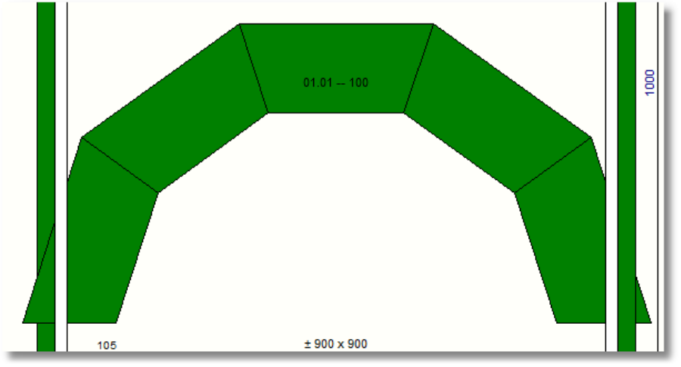

- DeleteShape (Index of the shape to delete into the shape array)

Suitable for unloading a shape from memory, deleting a given shape from the shape array. As for an example, at the end of a routine it may be useful to delete unnecessary shapes for drawings from shapes required from a given set up.
Anyway, WinPro always deletes the array content at the end of computation, but this instruction may be useful to free some more slots during computation.

- CopyShape (Source shape, Target shape)

Copy from a source shape to a target shape.
- Source shape : Shape to be copied.
- Target shape : Index of the shape that will be created.

Example :

CopyShape (_OutOuterFrameShapeNum, - 1)
This code copies the outside of outer frame shape (refer to list of predefined shapes above, _OutOuterFrameShapeNum) into a traget shape at the first available shape from the shape array (refer to basic notions above).

- RectangleIncludingShape (Shape index)

Transformation of a given shape into a rectangle including this shape.
- Shape index: Shape that will be transformed into rectangle containing the shape.

Example :

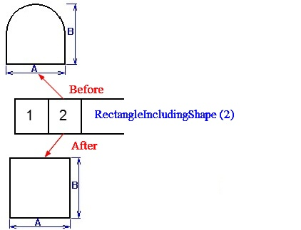
This instruction transforms shape number 2 from the shape array (full bow) into rectangle, the original full bow shape is overwritten.

- TransformShape (Shape index, Transformation type, p1, p2, p3, p4)

Operates a transformation of the defined shape into another shape, using a translation, a proportional transformation, a rotation or a symmetry.
Only specified Px settings are to be used, as an example for a type 1, do not leave the 2 last commas.
- Shape number : index of the shape to transform.
- Transformation type:
1 : Translation using a vector (0,0), (p1, p2).
2 : Proportional transformation of center (x,y) and factor (Fx, Fx). Uses settings p1, p2, p3.
3 : Rotation of center (x,y) and angle A. Uses settings p1, p2, p3.
4 : Orthogonal symmetry based on line crossing points (x1,y1) and (x2,y2). Uses settings p1, p2, p3, p4.
5 : Centrral symmetry of center (x1,y1). Uses settings p1, p2. This is equivalent to a proportional transformation (x1,y1,-1,-1), using settings p1, p2, p3, p4.

- CutShape (Source shape number, Left target shape number, Right target shape number, Angle, X Point, Y Point, Offset, Thickness)

Cuts a shape according a given line.
Anyway, be carefull when a closed shape is cut, the line should have 2 and only 2 crossing point with the shape. In case of opened shape, 1 point is enough.
- Index of source shape : Shape index that will bec ut into the shape array.
- Left target shape number: Number of the left hand shape from the line that will be created for closed shape, or the start of an opened shape.
- Right target shape number: Number of the right hand shape from the line that will be created for closed shape, or the end of an opened shape.
- Angle : Inclination of the segment cutting the shape.
- X point : X coordinate of the point where the line crosses. (Into global bench mark).
- Y point : Y coordinate of the point where the line crosses. (Into global bench mark).
- Offset : Segment offset perpendicularly to itself (with an offset, the segment do not crosses XY coordinate anymore). Positive = on the right, Negative = on the left.
- Thickness : Segment thickness (like a saw blade), centered to the segment. No negative value allowed.

Example :

# Loading shape of global filling
LoadShape (- 1, _FillingShapeNum,, FillingIndex)

# Storage of index of created shape into temporary variable
TmpGlobalPanelShapeNum := LastCreatedShapeNum [1]

# Step 1: sub shape creation, base shape is cut into two shapes
CutShape (TmpGlobalPanelShapeNum, - 1, - 1, 45, 0, _FillHeight [FillingIndex]/2, 0, 0)

# Storage of sub shapes indexes into temporary variables
TmpLeftPanelShapeNum:= LastCreatedShapeNum [1]
TmpRightPanelShapeNum:= LastCreatedShapeNum [2]
This code cuts a filling shape (TmpGlobalPanelShapeNum, see first LoadShape () instruction) by a segment of position X=0, Y=Height/2 (half height of the filling). Both sub shapes generated are stored into the first available slot of the shape array (values -1).
Temporary variable TmpLeftPanelShapeNum stores the left sub shape index into the shape array (variable LastCreatedShapeNum [1]), variable TmpRightPanelShapeNum stores the right sub shape index (variable LastCreatedShapeNum [2]).

- CutShapeHorizontally (Source shape index, Top target shape index, Bottom target shape index, Y point)

Cut in two a given shape according a horizontal segment.
- Source shape index : Shape to be cut.
- Top target shape index: Index of shape created on top of cutting segment. If value « -1 » is used for target shape, the first created is the bottom one, the second is the top one.
- Bottom target shape index: Index of shape created at the bottom of cutting segment. If value « -1 » is used for target shape, the first created is the bottom one, the second is the top one.
- Y point : Y position for the point crossed by the segment (Into global bench mark).

- CutShapeVertically (Source shape index, Left target shape index, Right target shape index, X point)

Cut in two a given shape according a vertical segment.
- Source shape index : Shape to be cut.
- Left target shape index: Index of shape created on the left of cutting segment. If value « -1 » is used for target shape, the first created is the right one, the second is the left one.
- Right target shape index: Index of shape created on the right of cutting segment. If value « -1 » is used for target shape, the first created is the bottom one, the second is the top one.
- X point : X position for the point crossed by the segment (Into global bench mark).

- ShrinkShape (Shape index, [Global shrink or Table of values or Shrink by side])

Shrinks the defined shape.
- Shape index: Shape to be shrinked.
- Global shrink : Shrink value for all sides.
or
- Table of values : Table of 8 shrink values for each side
or
- Shrink by side : List of shrink values (bottom, top, left, right, topleft, topright, bottomleft, bottomright).

- ExpandShape (Shape index, [Global shrink or Table of values or Shrink by side])

Expands the defined shape.
- Shape index: Shape to be expanded.
- Global shrink : Expand value for all sides.
or
- Table of values : Table of 8 expand values for each side
or
- Shrink by side : List of expand values (bottom, top, left, right, topleft, topright, bottomleft, bottomright).

- DeductShape (Source, Shape to deduct)

Deduct a defined shape from a source shape.
- Source : Shape to be modified, this shape will be overwritten.
- Shape to deduct : Shape that will be used as a mask.

Note :
It is not possible to deduct a shape when included into another (make a hole).

Example :

DeductShape (1, 2)
According below drawing, the source shape A is stored into shape array at index 1, the shape to be deducted is stored at index 1, the result shape C will be stored at index 1.

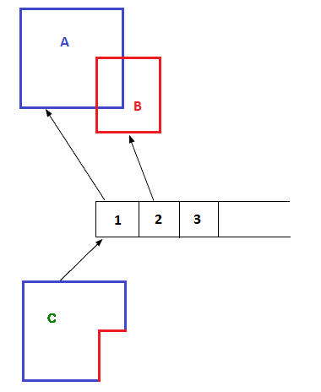

- MergeShape (Source, Shape to merge)

Merge a defined shape to a source shape.
- Source : The shape where the merge operation will be done, this shape will be modified.
- Shape to merge: Shape that will be merged to the first one. Attention, both shapes should share at least one segment.

Example :

MergeShape (1, 2)
According below drawing, source shape A is stored into shape array at index 1, the B shape to merge is stored at index 2, and result shape is stored at index 1.

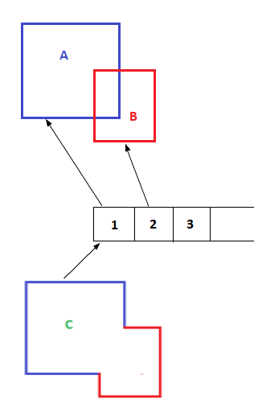

- IntersectionShape (Source, Shape to merge)

Merge a defined shape to a source shape.
- Source : Shape where the intersection is operated, this shape will be modified.
- Shape to merge : The shape that will be merged with the first one.

Example :

IntersectionShape (1, 2)
According below drawing, source shape A is stored into the index 1 of the shape array, shape to merge B is stored at index 2, and result shape at index 1.

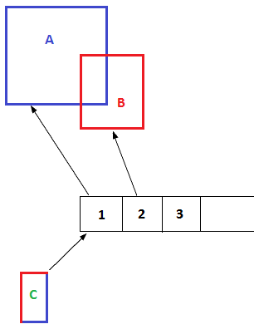

WinPro functions for creation and modification of shape filling « FWL »

Those functions allow to compute fillings (glass units, panels, security bars…) of shapes created by previous functions defined, as it is possible using functions FWL detailed into release note 7.1.00 (refer to FWL manual into main chm help file).

- CuttingFWLShape (Source shape index, Start target shape index, Angle, X, Y, CoefOffset, StartFlag, Thickness1, Thickness2, Clamp1, Clamp2, NbBoardForced, SpacingMin, SpacingMax)

This function defines filling options of a defined shape.
- Source shape index : Shape index that needs to be filled using FWLs.
- Start target shape index: Index of the shape for the first board or bar.
- Angle : Angle of the filling.
- X : Coordinate X of the reference point.
- Y : Coordinate Y of the reference point.
- CoefOffset : Coefficient allowing to modify the reference of start point proportionally to the dimension of board of thickness 1.
- StartFlag : Reference point for position of the first board.
* 1 for point of coordinates {x,y}.
* 2 for center of shape (difference between the uppest and lowest point, between the most on the left and the most on the right).
* 3 reference point is the most on the left.
* 4 reference point is the most on the right.
* In case of negative value (-1, -2, -3, and -4), the shape is filled with bars instead of boards.
- Thickness1 : Thickness of the first board or bar type.
- Epaisseur2 : Thickness of second board type or of the space between bars in case of security bar.
Clamp1 : Clamping value for boards of the first type.
Clamp2 : Clamping value for boards of the second type.
NbBoardForced : Forces the number of final boards.
SpacingMin : Minimum spacing between 2 bars.
SpacingMax : Maximum spacing between 2 bars.

WinPro function of shape set up

Those instructions allow to modify shape, segment by segment. 2 existing syntaxes, with 4 or 5 settings.

Instruction with 4 settings:
- SetupShapeInfo (Shape index, Absolute segment index, Modification type, Value)

This version with 4 settings is designed to set up or modify many caracetristics from a segment.
- Shape index: Index of shape to be modified.
- Absolute segment index : Segment index without relationship with a given side. For instance into basket handle shape with 3 centers, segments of the bow are n° 1, 2 and 3, starting at 0 with left side.
- Modification type : Type of modification to operate. Attention, modification must be granted first for the shape (type « -200 »), and must be finalized with closing shape set up (type « -100 »).
* 0 : Number of absolute segments.
* 1 : Segment type (0 for straight, 1 for arch, 3 for ellipse).
* 2 : X0 of segment.
* 3 : Y0 of segment.
* 4 : X1 of segment.
* 5 : Y1 of segment.
* 6 : X of the arch center or of the first arch center in case of ellipse.
* 7 : Y of the arch center or of the first arch center in case of ellipse.
* 8 : X of the second arch center for an ellipse.
* 9 : Y of the second arch center for an ellipse.
* 10 : Arch radius.
* 11 : Value « 0 » for an arch segment, « 1 » for a circle (Bull eye).
* 12 : Arch rotation. « 1 » for anticlockwise, « 0 » for clockwise.
* -9 : Sets if the shape is opened (1) or closed (0).
* -10 : Forces or not the locking of position for computation. Remains unused usually, may corrupt computation in case of bad use.
* 28 : Defines a label for a segment (sub side in absolute), allows to fix an information to name a side for instance.
* 29 : Side label, Winpro side name. Useful to name sides in case of shrink for instance. See function ShapeSideInfo () .
* -200 : Allows shape modification.
* -100 : Finalize the shape set up.

Example :

# Creation of a shape
CreateShape(- 1, CompleteBasketHandle, 1000, 1000, 300)
# Loading into a variable of shape index within shape array
TempShape := LastCreatedShapeNum [1]
# Shape modification granted
SetupShapeInfo (TempShape, 0, - 200, 0)

Instruction with 5 settings :
- SetupShapeInfo (Shape index, Segment index, , InfoOperation, TabSeg)

This instruction is designed to integrate, replace… a segment.
Attention, a 4 settings syntax instruction is needed before and after to grant and close modification, grant modification with type « -200 » then finalize with closing shape definition with type « -100 ».
- Shape number : Shape to be modified.
- Segment number : Segment number to be modified in absolute, corresponds to absolute sub side number.
- Unused, leave this setting empty.
- InfoOperation : Operation type.
* 0 to add a segment at the end (« segment n°» ignored)
* 1 to overwrite a segment
* 2 to insert a segment
* 3 to delete a segment (in this case, variable « tabSeg » is not relevant)
- TabSeg : Array variable of 40 positions, instructions read are the following :
* 1 : sub side type (0 for straight, 1 for arch, 3 for ellipse).
* 2 : X0 of segment.
* 3 : Y0 of segment.
* 4 : X1 of segment.
* 5 : Y1 of segment.
* 6 : X of center of the arch or first arch center in case of ellipse.
* 7 : Y of center of the arch or first arch center in case of ellipse
* 8 : X of center of second arch for ellipse.
* 9 : Y of center of second arch for ellipse.
* 10 : Arch radius.
* 11 : « 0 » for an arch segment, « 1 » for a circle (Bull eye).
* 12 : Arch rotation. « 1 » for anticlockwise, « 0 » for clockwise.
* 28 : Defines a label for a segment (sub side in absolute), allows to fix an information to name a side for instance.
* 29 : Side label, Winpro side name. Useful to name sides in case of shrink for instance. See function ShapeSideInfo () .

Examples :

tmp : 40
tmp:= 0
tmp [2] := 870
tmp [3] := 1095
tmp [4] := 870
tmp [5] := 935
tmp [29] := 2

SetupShapeInfo (100, 2,, 3, tmp)
SetupShapeInfo (100, 2, 10, 780)

tmp: 30
tmp:= 0
tmp [1] := 1
tmp [2] := 160
tmp [3] := 1095
tmp [4] := 310
tmp [5] := 1095
tmp [6] := 160
tmp [7] := 1295
tmp [10] := 200
tmp [12] := 1
tmp [29] := 4

SetupShapeInfo (100, 2,, 2, toto)
SetupShapeInfo (100, 11,, 3, toto)

tmp : 30
tmp := 0
tmp [2] := 160
tmp [3] := 935
tmp [4] := 130
tmp [5] := 935
tmp [29] := 8

SetupShapeInfo (100,,, 0, toto)

WinPro function for creation and modification of boards

Those functions allow creating and modifying the boards from a filling.

- ShrinkBoardShape (Shape index, Angle, LeftShrink, EndShrink, RightShrink, StartShrink)

Shrinks a board. Specifically designed for boards and transoms, but may be used with any shape, as soon as 2 sides are parallel to Angle.
- Shape index : Shape index to shrink into the shape array.
- Angle : Shape inclination (possible only if two sides are parallels).
- LeftShrink : Shrink for left side of the shape (oriented with the start in the back and the end in front of).
- EndShrink : Shrink for the end of the shape (oriented with the start in the back and the end in front of).
- RightShrink : Shrink for the right side of the shape (oriented with the start in the back and the end in front of).
- StartShrink : Shrink for the start of the shape (oriented with the start in the back and the end in front of).

- ConvertCurvesIntoLinesShape (Shape index, ConversionType)

Convert a complex shape into straight shape, contained or containing.
- Shape index : Shape to be converted
- ConvesionType : type of conversion of the complex shape.
* 1 result is shape contained into curves.
* 0 result is shape containing the curves.

Example :
ConvertCurvesIntoLinesShape (100, 0)
Convert shape of index 100 into the shape array (circle, bulleye) into containing shape.
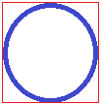

ConvertCurvesIntoLinesShape (100, 1)
Convert shape of index 100 into the shape array (circle, bulleye) into contained shape.
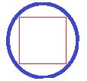

WinPro creation and modification functions for shapes of boards

Those functions are designed to be interrogated in order to extract needed information.

3 possible variants:

- GetShapeInfo (Shape index)

Debug mode. WinPro’s computation is stopped and a informative dialog appears with main information from shape.
Example :
GetShapeInfo (TmpPanelGlobShapeNum)
Debugs the shape of index « TmpPanelGlobShapeNum » into the shape array.

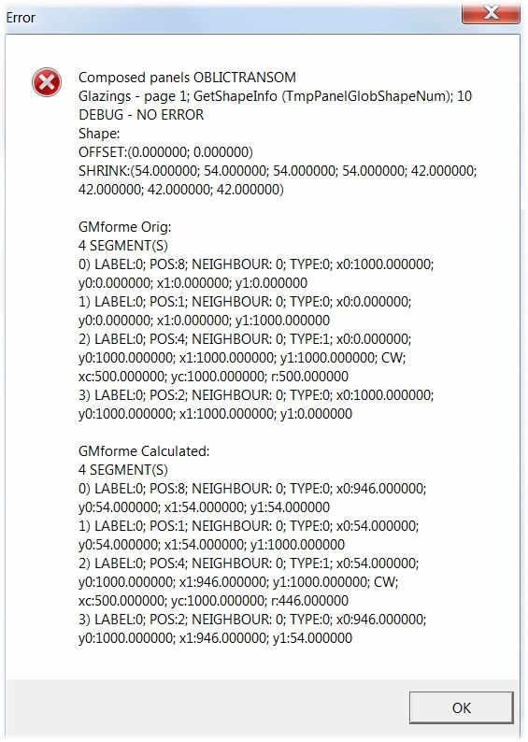

- GetShapeInfo (Shape index, Side name, Side index, Sub side index)

Basic instruction that runs computation before using the following (ShapeInfo (), SideShapeInfo () and SubSideShapeInfo ()).
- Shape index : Shape number to be queried.
- Side name : Standard Winpro side (Top, Bottom, ….) to interrogate. Side name or side number, but not at the same time.
- Side index: Side number to query. Start at « 0 ». Side name or side number, not both.
- Sub side index : Sub side number into the side to be queried, starting at « 1 ».
With a zero value, an array is filled with values from all sub side of a side, GetSubSideInfo. For the « n » sub side, the info labelled « i » is located into slot (n-1) x 40 + i.
For instance, for a sub side, the first setting is rached with: (n-1) x 40 + i = (1-1) x 40 + 1
For 2 sub sides, setting 1 of sub side 2 : (n-1) x 40 + i = (2-1) x 40 + 1

Example :

GetShapeInfo (100,,,)
This runs the computation, and fills variables ShapeInfo (), SideShapeInfo () and SubSideShapeInfo () for shape of index 100 into the shape array.

GetShapeInfo (1,,1,2)
Computation is executed onto shape « 1 », the side number « 1 » and sub side number « 2 » (of side n°« 1 »). Global information of the shape is retrieved, along with side and sub side information.

- GetShapeInfo (Shape index, Side name, Side index, Sub side index [, Start shape index, Middle shape index, End shape index, Assembled shape index, Start assembly, End assembly, Thickness previous sub side, Thickness current sub side, thickness next sub side, Thickness other sub side])

This instruction queries the shape, at this step WinPro fills variables ShapeInfo, SideShapeInfo, SubSideShapeInfo, and shape corresponding to profiles and their assembly join are created.
LastCreatedShapeNum [1] returns the assembly shape for start of profile of sub side 1.
LastCreatedShapeNum [2] returns the shape for middle of profile of sub side 1.
LastCreatedShapeNum [3] returns the assembly shape for end of profile of sub side 1.
LastCreatedShapeNum [4] returns the global shape of profile of sub side 1.
LastCreatedShapeNum [5] returns the assembly shape for start of profile of sub side 2.
LastCreatedShapeNum [6] returns the shape for middle of profile of sub side 2.
LastCreatedShapeNum [7] returns the assembly shape for end of profile of sub side 1.
LastCreatedShapeNum [8] returns the global shape of profile of sub side 1.
And so on, as many times as sub sides.
- Shape index : Index of shape to query.
- Side name : Standard classique side name (Top, Bottom, ….) to query. Name or number of the side, but not both.
- Side index : Index of side to query, starting at « 0 ». Name or number of the side, but not both.
- Sub side index : Index of sub side into the side to query, starting at « 1 ».
Refer to previous instruction.

Next information, optional, are used to compute complex surface, related to thermic module for instance. The three following datas correspond to a shape index to store computed information.

Example :

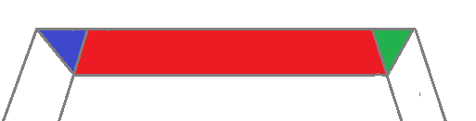

We need here to store blue shape into index n° 15, red into 16 and green into 17.
The computation for start shape and end shape correponds to a type 4 assembly join, whatever is the real assembly join.
In case of impossible calculation, the next side returns the complement for the sum of all computed shapes for all sub sides to be equal to the real profile surface of the frame.

Example of join returning an impossible computation:
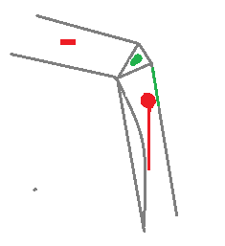

Example of complete setup with particular cases:
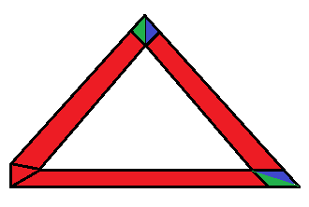
- Start shape index: Shape index for storage of the computed shape.
- Middle shape index : Shape index for storage of the computed shape.
- End shape index : Shape index for storage of the computed shape.
- Assembled shape index : Shape index for storage of the computed shape, for a sub side and with real assembly joins, which means shape of the real sub side. It is worth -1 most of the time.
- Start assembly : Defines the start assembly type.
Attention, if the sub side index is zero, this assembly join represents the start of side and not the start of sub side.
* 0 : Standard WinPro mitre cut (bissectrice of the inside angle).
* 1 : Long straight.
* 2 : Short straight.
* 3 : Door bottom (like long straight).
* 4 : Between segments (unused).
* 5 : Standard WinPro miter (like 0) but with also computing values for horn cutting in case of mixed sections.
* 6 : Absolute miter (cut from inside to outside angle), different from 0 in case of 2 sub side of mixed sections.
- End assembly : Defines the end assembly type.
Attention, if the sub side index is zero, this assembly join represents the end of side and not the start of sub side.
* 0 : Standard WinPro miter cut (bissectrice of the inside angle).
* 1 : Long straight.
* 2 : Short straight.
* 3 : Door bottom (like long straight).
* 4 : Between segments (unused).
* 5 : Standard WinPro miter (like 0) but with also computing values for horn cutting in case of mixed sections.
* 6 : Absolute miter (cut from inside to outside angle), different from 0 in case of 2 sub side of mixed sections.
- Thickness for previous sub side : Value of thickness from previous sub side, necessary for a correct computation of assembly joins.
- Thickness for current sub side : Value for thickness of current side.
- Thickness for next sub side : Value for thickness of next side.
- Thickness for others sub sides : Value for thickness of other sides. Never leave the field empty.

- ShapeInfo [setting]

Extract shape infos from the shape array, after running instruction GetShapeInfo () into current code.
- setting : Type of information required. Returned values :
* 1 : shape number into the list of WinPro’s available shapes, value 37 is for free shape.
0 : Rectangle
1 : Trapezium
2 : Right Angled Triangle
3 : Truncated Corner
4 : Right Angled Trapezium
5 : Bow
6 : Full Bow
7 : Half Full Bow
8 : Flat Bow
9 : Half Flat Bow
10 : Truncated Bow
11 : Rounded Corner
12 : Triangle
13 : Quadrilateral
14 : Simple Trapezium
15 : Truncated Corner 2
16 : Pentagon
17 : Truncated Trapezium
18 : Basket Handle (3 centers)
19 : Truncated Basket Handle (3 centers)
20 : Bull eye
21 : Complete Basket Handle (3 centers)
22 : Hald Basket Handle (3 centers)
23 : Basket Handle (5 centers)
24 : Truncated Basket Handle (5 centers)
25 : Complete Basket Handle (5 centers)
26 : Half Basket Handle (5 centers)
27 : Reversed Trapezium
28 : Reversed Rectangle Triangle
29 : Reversed Truncated Corner
30 : Reversed Rectangle Trapezium
31 : Reversed Triangle
32 : Reversed Quadrilateral
33 : Simple Reversed Trapezium
34 : Reversed Truncated Corner 2
35 : Reversed Pentagon
36 : Reversed Truncated Trapezium
37 : Free Shape
38 : Truncated Rounded Corner
39 : Ellipse 4 centers
40 : Ogive
41 : Free Triangle
* 2 : Number od standard WinPro sides.
* 3 : Number of segments in absolute.
* 4 : X of bottom left corner of the rectangle containing the shape.
* 5 : Y of bottom left corner of rectangle containing the shape.
* 6 : X of top right corner of the rectangle containing the shape.
* 7 : Y of top right corner of the rectangle containing the shape.
* 8 : Shape surface (into mm²).
* 9 : Set to 0 when shape is closed, 1 if shape is opened.
* 10 : Position locked. Sets that positions defined by user are locked, WinPro was not granted to change positions set with instruction GetShapeInfo ().

- SideShapeInfo [setting]

Extract side information from a shape of the shape array, after instruction GetShapeInfo () into current code.
- setting : Type of information queried. Returned values:
* 1 : Number of sub sides of a side.
* 2 : Standard WinPro side name.
* 3 : Side number.
* 4 : Side label :
0 : No label (usually impossible, to test integrity of created shape).
1 : Left
2 : Right
4 : Top
8 : Bottom
16 : Top left
32 : Top right
64 : Vertical (usually impossible because related to transoms)
128 : Horizontal (usually impossible because related to transoms)
256 : Bottom left
512 : Bottom right
* 5 : Side length (sum of sub sides lengths).

- SubSideShapeInfo [setting]

Extract sub side information from a shape of the shape array, after instruction GetShapeInfo () into current code.
When a query is made through instruction GetShapeInfo () with setting 0 for the sub side index, variable SubSideShapeInfo is filled with information of all sub sides. To distinguish sub sides, indexes from 1 to 32 is for the first sub side (33 to 40 remains unused currently), 41 to 72 for the second (73 to 80 unused), etc.

E.g.:
Searched index (1 to 32) + 40 * (sub side number – 1)
Then, for index 10 (arch radius) of sub side 2:
SubSideShapeInfo [10 + 40 * (2 – 1)] = SubSideShapeInfo [50].

- setting : Type of information queried. Returned values :
* 1 : Sub side type (0 for straight, 1 for arch, 3 for ellipse).
* 2 : X0.
* 3 : Y0.
* 4 : X1.
* 5 : Y1.
* 6 : X of arch center or of first arch center in case of ellipse.
* 7 : Y of arch center or of first arch center in case of ellipse.
* 8 : X of center of second arch for an ellipse.
* 9 : Y of center of second arch for an ellipse.
* 10 : Arch radius.
* 11 : « 0 » for zan arch segment, « 1 » for a circle (Bull eye).
* 12 : Arch rotation, « 1 » for anticlockwise, « 0 » for clockwise.
* 13 : Sub side length.
* 14 : Sub side inclination (inclination of segment X0, Y0 ; X1, Y1).
* 15 : X0 but considering also the assembly type.
* 16 : Y0 but considering also the assembly type.
* 17 : X1 but considering also the assembly type.
* 18 : Y1 but considering also the assembly type.
* 19 : Left start angle, corresponds to angle from side (X0 ; Y0) on the left of segment {X0, Y0 ; X1, Y1}, into yellow colour on the drawing. For a frame different from a fixed transom at 90°. See below drawing.
* 20 : Start right angle, into green on the drawing. See below..
* 21 : Start cut, see below.
* 22 : Start offset, see below.
* 23 : End left angle into yellow on the drawing, angle fin gauche en jaune sur le dessin. For a frame different from a fixed transom at 90°. See below drawing.
* 24 : End right angle into green, see below.
* 25 : End cut, see below.
* 26 : End offset, see below.
* 27 : Length of sub side considering assembly type.
Take care of particular case, it is worth « -1 » in case of computation problem.
* 28 : Segment label (sub side into absolute). 1000 = start; 2000 = outside; 3000 = end; 4000 = inside.
Example:

If SubSideShapeInfo [28] = 2000
or
If SubSideShapeInfo [28] = Outside

* 29 : Side label (same as SideShapeInfo [4]).
* 30 : Segment number (sub side number in absolute).
* 31 = DirectionStartSegment, tangent angle at start point of the sub side.
* 32 = DirectionEndSegment, tangent angle at sub side end.
For a straight segment, [14] = [31] = [32], for a curved segment the 3 values are different.

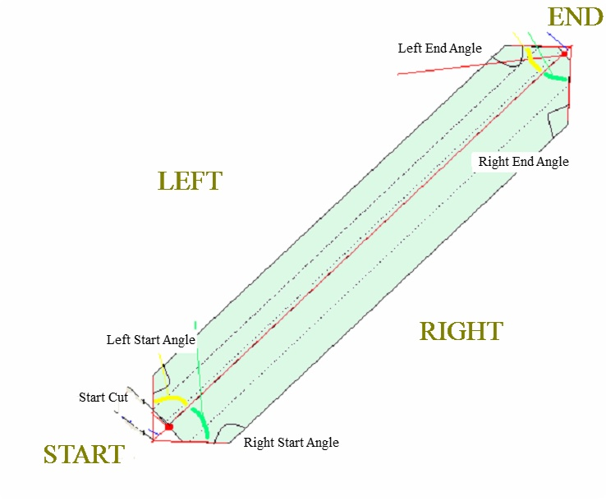

WinPro function of computation result for shape filling « FWL »

Those functions are designed to query the shape array about the shape fillings in order to extract needed data.

- NbBoradCut

Local variable returning the number of boards calculated, after running instruction CuttingFWLShape ().

- GetBoardShapeInfo (Source shape index, Angle)

This is suitable for any shape without running FWL initialization instruction. Anyway, the concerned shape must have 2 parallel sides at least, and be composed of straight absolute segments (no bow).
- Source shape index : Shape index of the board that is to be queried for extracting computation result.
- Angle : Angle defined into instruction CuttingFWLShape ().

Once instruction GetBoardShapeInfo () is run for a board (or a bar), function ShapeInfo () allows to know the various information about a board or a bar (array from 11 to 24).
- ShapeInfo [11] returns « X0 ».
- ShapeInfo [12] returns « Y0 ».
- ShapeInfo [13] returns « X1 ».
- ShapeInfo [14] returns « Y1 ».
- ShapeInfo [15] returns « AngleSL ».
- ShapeInfo [16] returns « AngleSR ».
- ShapeInfo [17] returns « CoupeR ».
- ShapeInfo [18] returns « OffsetS ».
- ShapeInfo [19] returns « AngleEL ».
- ShapeInfo [20] returns « AngleER ».
- ShapeInfo [21] returns « CuttingE».
- ShapeInfo [22] returns « OffsetE ».
- ShapeInfo [23] returns « TotalLength ».
- ShapeInfo [24] returns « ThicknessMax ».

WinPro functions for cutting shape

Those functions allow to consummate window elements (profiles, articles, labours, …).

- ShapeNumToCut

Used to consummate a shape for a filling (into panel rules for instance)

Example :

- ShapeNumToCut := Shape index
Consummate the shape of specified index.

- DrawShape (Shape index, X, Y)

This instruction allows to draw the outline of the defined shape into a WinPro drawing.

Examples :

DrawShape (1, 0, 0)
Draw shape of index 1 from the shape array at position (0,0).

or

PenColour (_OuterFrameIntLineColourRed, _OuterFrameIntLineColourGreen, _OuterFrameIntLineColourBlue)
Brush (Colour, _OuterFrameIntColourRed, _OuterFrameIntColourGreen, _OuterFrameIntColourBlue)
StartPath ()
DrawShape (1, 0, 0)
EndPath ()
FillAndBorderPath ()
This code draws shape of index 1 from the shape array, with line and fill colour from outer frame.

Installation of a report for data exportation

A WPR report allows to retrieve the whole set of computed values and to export them toward 3 tables, , InfoForme, InfoBordForme and InfoSousBordForme.
Data type « double », corresponding to values with decimals, are first multiplied by 1000000 into the code then returned to appropriate unit into export tables, this to keep a maximum of accuracy with decimals.

WpReport functions of shape definition/modification

Those instructions are designed to generate shapes to be used into user defined reports.

- CreerTableauForme(x : Integer) : Boolean

This function create the shape array. Into data set up the shape array is existing an dis composed of 500 slot, where the shape array needs to be defined manually into WPR, size included. First index is value « 1 ».
- X : Size of array.

The function returns True or False according the calculation result.

Examples :

tmp_test1 := CreerTableauForme(100);
if tmp_test1 = false then showmessage('computation error with function « CreerTableauForme »');
This WPR code creates a shape array with 100 cells, and returns an error message in case of problem.

- DefinirInfoForme (Shape index, Segment index, Modification type, value)

That’s the function corresponding to SetupShapeInfo () with 4 settings from WinPro, as detailed above. It allows defining or modifying various settings for a segment.
- Shape index : Shape to be modified
- Segment index : Segment index (sub side in absolute), starting at 0.
- Modification type : Type of modification to do. Attention, modification must always be finalized with closing the shape definition (type « -100 »), but there is no need to start with granting modification of the shape as into WinPro’s code.
* 0 : Number of absolute sub segments.
* 1 : Sub side type (0 for straight, 1 for arch, 3 for ellipse).
* 2 : X0.
* 3 : Y0.
* 4 : X1.
* 5 : Y1.
* 6 : X of the arch center or of the first arch center in case of ellipse.
* 7 : Y of the arch center or of the first arch center in case of ellipse.
* 8 : X of the second arch center for an ellipse.
* 9 : Y of the second arch center for an ellipse.
* 10 : Arch radius.
* 11 : Value « 0 » for an arch segment, « 1 » for a circle (Bull eye).
* 12 : Arch rotation. « 1 » for anticlockwise, « 0 » for clockwise.
* -9 : Sets if the shape is opened (1) or closed (0).
* -10 : Forces or not the locking of position for computation. Remains unused usually, may corrupt computation in case of bad use.
* 28 : Defines a label for a segment (sub side in absolute), allows to fix an information to name a side for instance.
* 29 : Side label, Winpro side name. Useful to name sides in case of shrink for instance. See function ShapeSideInfo () .
* -100 : Finalize the shape set up.

Exemples :

tmp_num_shape := 10;

tmp_test1 := DefinirInfoForme(tmp_num_shape,0,0,3);

tmp_test1 := DefinirInfoForme(tmp_num_shape,0,1,0);
tmp_test1 := DefinirInfoForme(tmp_num_shape,0,2,100);
tmp_test1 := DefinirInfoForme(tmp_num_shape,0,3,100);
tmp_test1 := DefinirInfoForme(tmp_num_shape,0,4,100);
tmp_test1 := DefinirInfoForme(tmp_num_shape,0,5,200);
tmp_test1 := DefinirInfoForme(tmp_num_shape,0,29,1);

tmp_test1 := DefinirInfoForme(tmp_num_shape,1,1,0);
tmp_test1 := DefinirInfoForme(tmp_num_shape,1,2,100);
tmp_test1 := DefinirInfoForme(tmp_num_shape,1,3,200);
tmp_test1 := DefinirInfoForme(tmp_num_shape,1,4,300);
tmp_test1 := DefinirInfoForme(tmp_num_shape,1,5,100);
tmp_test1 := DefinirInfoForme(tmp_num_shape,1,29,32);

tmp_test1 := DefinirInfoForme(tmp_num_shape,2,1,0);
tmp_test1 := DefinirInfoForme(tmp_num_shape,2,2,300);
tmp_test1 := DefinirInfoForme(tmp_num_shape,2,3,100);
tmp_test1 := DefinirInfoForme(tmp_num_shape,2,4,100);
tmp_test1 := DefinirInfoForme(tmp_num_shape,2,5,100);
tmp_test1 := DefinirInfoForme(tmp_num_shape,2,29,8);

- DefinirSegmentForme (Shape index, Segment index, , InfoOperation, TabSeg)

This instruction corresponds to DefinirInfoForme () with 5 settings into Winpro, and allows integrating, replacing… a segment.
Attention, a 4 settings syntax instruction is needed before and after to grant and close modification, grant modification with type « -200 » then finalize with closing shape definition with type « -100 ».
- Shape number : Shape to be modified.
- Segment number : Segment number to be modified in absolute, corresponds to absolute sub side number.
- Unused, leave this setting empty.
- InfoOperation : Operation type.
* 0 to add a segment at the end (« segment n°» ignored)
* 1 to overwrite a segment
* 2 to insert a segment
* 3 to delete a segment (in this case, variable « tabSeg » is not relevant)
- TabSeg : Array variable of 40 positions, instructions read are the following :
* 1 : sub side type (0 for straight, 1 for arch, 3 for ellipse).
* 2 : X0 of segment.
* 3 : Y0 of segment.
* 4 : X1 of segment.
* 5 : Y1 of segment.
* 6 : X of center of the arch or first arch center in case of ellipse.
* 7 : Y of center of the arch or first arch center in case of ellipse
* 8 : X of center of second arch for ellipse.
* 9 : Y of center of second arch for ellipse.
* 10 : Arch radius.
* 11 : « 0 » for an arch segment, « 1 » for a circle (Bull eye).
* 12 : Arch rotation. « 1 » for anticlockwise, « 0 » for clockwise.
* 28 : Defines a label for a segment (sub side in absolute), allows to fix an information to name a side for instance.
* 29 : Side label, Winpro side name. Useful to name sides in case of shrink for instance. See function ShapeSideInfo () .

- RectangleContenantForme (ShapeIndex); Booléen

Transformation of a defined shape into a rectangle containing the shape.
- Shape index : Shape to be transformed into a rectangle containing the shape.
Returns True or False when transformation is a success or not.

- SupprimerForme (Shape index).

This functions purges shapes loaded into memory. For instance at the end of a routine using shapes for consumption and not for drawings, unused shapes may be purged from the shape array.

- CopierForme (Source shape, Target shape)

Copy of source shape toward a target shape.
Source shape index : Shape index to be copied.
Target shape index : Shape index to be created.

- CouperForme (Source shape index, Left target shape index, Right target shape index, Angle, X point, Y point, Offset, Thickness)

Cuts a shape according a given line.
Anyway, be careful when a closed shape is cut, the line should have 2 and only 2 crossing point with the shape. In case of opened shape, 1 point is enough.
- Source shape index : Shape index that will be cut into the shape array.
- Left target shape number: Number of the left hand shape from the line that will be created for closed shape, or the start of an opened shape.
- Right target shape number: Number of the right hand shape from the line that will be created for closed shape, or the end of an opened shape.
- Angle : Inclination of the segment cutting the shape.
- X point : X coordinate of the point where the line crosses. (Into global bench mark).
- Y point : Y coordinate of the point where the line crosses. (Into global bench mark).
- Offset : Segment offset perpendicularly to itself (with an offset, the segment do not crosses XY coordinate anymore). Positive = on the right, Negative = on the left.
- Thickness : Segment thickness (like a saw blade), centered to the segment. No negative value allowed.

- CouperFormePar1Segment (Source shape index, Left target shape index, Right target shape index, X0, Y0, X1, Y1)

Cut a defined shape according a given segment {X0, Y0} → {X1, Y1}.
Be careful anyway, if a closed shape is cut, the segment cutting the shape must have two and only two intersection point with the shape whereas in case of opened shape, one point is sufficient.
- Source shape index : Shape index to bec ut into shape array.
- Left target shape index : Shape index that will be created on the left of the segment cutting for closed shapes, otherwise it is the start of an opened shape.
- Right target shape index : Shape index that will be created on the right of the segment cutting for closed shapes, otherwise it is the end of an opened shape.
- X0 : X coordinate of the segment start (Into global bench mark).
- Y0 : Y coordinate of the segment start (Into global bench mark).
- X1 : X coordinate of the segment end (Into global bench mark).
- Y1 : Y coordinate of the segment end (Into global bench mark).

- TransformerForme (Shape index, Transformation type, p1, p2, p3, p4)

Operates a transformation of the defined shape into another shape, using a translation, a proportional transformation, a rotation or a symmetry.
Only specified Px settings are to be used, as an example for a type 1, do not leave the 2 last commas.
- Shape index : index of the shape to transform.
- Transformation type:
1 : Translation using a vector (0,0), (p1, p2).
2 : Proportional transformation of center (x,y) and factor (Fx, Fx). Uses settings p1, p2, p3.
3 : Rotation of center (x,y) and angle A. Uses settings p1, p2, p3.
4 : Orthogonal symmetry based on line crossing points (x1,y1) and (x2,y2). Uses settings p1, p2, p3, p4.
5 : Centrral symmetry of center (x1,y1). Uses settings p1, p2. This is equivalent to a proportional transformation (x1,y1,-1,-1), using settings p1, p2, p3, p4.

- SoustraireForme (Source, Shape to deduct)

Deduct a defined shape from a source shape.
- Source : Shape to be modified, this shape will be overwritten.
- Shape to deduct : Shape that will be used as a mask.

Note :
It is not possible to deduct a shape when included into another (make a hole).

- UnionForme (Source, Shape to merge)

Merge a defined shape to a source shape.
- Source : The shape where the merge operation will be done, this shape will be modified.
- Shape to merge: Shape that will be merged to the first one. Attention, both shapes should share at least one segment.

- IntersectionForme (Source, Shape to merge)

Merge a defined shape to a source shape.
- Source : Shape where the intersection is operated, this shape will be modified.
- Shape to merge : The shape that will be merged with the first one.

- ReduireForme (Shape index, [Global shrink or Table of values or Shrink by side])

Shrinks the defined shape.
- Shape index: Shape to be shrinked.
- Global shrink : Shrink value for all sides.
or
- Table of values : Table of 8 shrink values for each side
or
- Shrink by side : List of shrink values (bottom, top, left, right, topleft, topright, bottomleft, bottomright).

- FiltrerSurLabelForme (Shape index, Keep; label1, label2, label3, label4)

- Shape index: Shape to be filtered.
- Keep : When this fiel dis set to True, only listed segments are kept, segment where keep is worth False are deleted.
- label1 → label4 : List of labels to test.

- ContientPoint(Shape index, pointX, pointY) ; Boolean

Test if a point is within a shape or not.
- Shape index : Shape to be tested.
- PointX : Coordinate X of the point to be tested.
- PointY : Coordinate Y of the point to be tested.
Returns True when the point is within the shape, False otherwise.

WpReport milling functions

Those functions generate complex milling operations straight into WPR, for pantographs machine for instance.

- AjouterCornesForme (Shape index, Length before start, Start radius, Start rotation, Length start, Length end, End radius, End rotation, length after end)

Before running this function, the shape should be modified to transform it into an opened shape, when required.
Allows to add horns into a shape.
- Shape index: Shape index where horns will be added.
- Length before start : Length of straight segment before beginning. May be null.
- Start radius : Radius of ¼ of circle of the beginning.
- Start rotation : Determines if the beginning is done toward top or bottom, depending on rotation of the tool.
- Start length : Segment length after the arch and before the part. Same type as the first segment of the shape (arch or straight).
- Length before end : Length of straight segment before beginning. May be null.
- End radius : Radius of ¼ of circle of the beginning.
- Sens rotation fin : Determines if the beginning is done toward top or bottom, depending on rotation of the tool.
- End length : Segment length after the arch and before the part. Same type as the first segment of the shape (arch or straight).
The second part of the horn is done at the end of last segment of the shape.

WpReport functions of computation results

- ObtenirInfoForme (Shape index, Segment index, Array variable for shape values, Array variable for segment values)

Queries the shape.
- Shape index : The shape to be queried.
- Segment index : The segment to be queried (sub side in absolute).
- Array variable for shape values : Name of the array variable that will be filled with information about the shape. Similar to instruction ShapeInfo () in WinPro : Array of 11 cells (from 0 to 10, only below cells are filled) :
- 1 : Shape number into the list of WinPro’s shape, with shape 37 as free shape.
0 : Rectangle
1 : Trapezium
2 : Right Angled Triangle
3 : Truncated Corner
4 : Right Angled Trapezium
5 : Bow
6 : Full Bow
7 : Half Full Bow
8 : Flat Bow
9 : Half Flat Bow
10 : Truncated Bow
11 : Rounded Corner
12 : Triangle
13 : Quadrilateral
14 : Simple Trapezium
15 : Truncated Corner 2
16 : Pentagon
17 : Truncated Trapezium
18 : Basket Handle (3 centers)
19 : Truncated Basket Handle (3 centers)
20 : Bull eye
21 : Complete Basket Handle (3 centers)
22 : Hald Basket Handle (3 centers)
23 : Basket Handle (5 centers)
24 : Truncated Basket Handle (5 centers)
25 : Complete Basket Handle (5 centers)
26 : Half Basket Handle (5 centers)
27 : Reversed Trapezium
28 : Reversed Rectangle Triangle
29 : Reversed Truncated Corner
30 : Reversed Rectangle Trapezium
31 : Reversed Triangle
32 : Reversed Quadrilateral
33 : Simple Reversed Trapezium
34 : Reversed Truncated Corner 2
35 : Reversed Pentagon
36 : Reversed Truncated Trapezium
37 : Free Shape
38 : Truncated Rounded Corner
39 : Ellipse 4 centers
40 : Ogive
41 : Free Triangle
- 2 : Number of standard WinPro sides.
- 3 : Number of segments in absolute.
- 4 : X of bottom left corner of the rectangle containing the shape.
- 5 : Y of bottom left corner of rectangle containing the shape.
- 6 : X of top right corner of the rectangle containing the shape.
- 7 : Y of top right corner of the rectangle containing the shape.
- 8 : Shape surface (into mm²).
- 9 : Set to 0 when shape is closed, 1 if shape is opened.
- 10 : Position locked. Sets that positions defined by user are locked, WinPro was not granted to change positions set with instruction GetShapeInfo ().
- Array variable for segment values : Array variable name that will be filled with information from segment of the shape. Same instruction as ShapeSubSideInfo () in WinPro : Array of 33 cells (from 0 to 32, only below cells are filled).
* 1 : Sub side type (0 for straight, 1 for arch, 3 for ellipse).
* 2 : X0.
* 3 : Y0.
* 4 : X1.
* 5 : Y1.
* 6 : X of arch center or of first arch center in case of ellipse.
* 7 : Y of arch center or of first arch center in case of ellipse.
* 8 : X of center of second arch for an ellipse.
* 9 : Y of center of second arch for an ellipse.
* 10 : Arch radius.
* 11 : « 0 » for zan arch segment, « 1 » for a circle (Bull eye).
* 12 : Arch rotation, « 1 » for anticlockwise, « 0 » for clockwise.
* 13 : Sub side length.
* 14 : Sub side inclination (inclination of segment X0, Y0 ; X1, Y1).
* 15 : X0 but considering also the assembly type.
* 16 : Y0 but considering also the assembly type.
* 17 : X1 but considering also the assembly type.
* 18 : Y1 but considering also the assembly type.
* 19 : Left start angle, corresponds to angle from side (X0 ; Y0) on the left of segment {X0, Y0 ; X1, Y1}, into yellow colour on the drawing. For a frame different from a fixed transom at 90°. See below drawing.
* 20 : Start right angle, into green on the drawing. See below..
* 21 : Start cut, see below.
* 22 : Start offset, see below.
* 23 : End left angle into yellow on the drawing. For a frame different from a fixed transom at 90°. See below drawing.
* 24 : End right angle into green, see below.
* 25 : End cut, see below.
* 26 : End offset, see below.
* 27 : Length of sub side considering assembly type. It is worth « 0 » in case of computation problem. In case of computation for outside outer frame dimension, this value corresponds to AdjustedDimension [SubSideIndex].
* 28 : Segment label du segment (sub side in absolute), 1000=start, 2000=outside, 3000=end, 4000=other.
* 29 : Segment label, same as ShapeSideInfo [4].
* 30 : Segment number (sub side number in absolute).
* 31 = DirectionStartSegment, tangent angle to the start point of the sub side.
* 32 = DirectionEndSegment, tangent angle to the end point of the sub side.
For a straight segment, [14] = [31] = [32], for a curved one, all values are different.
- DebugForme(Shape index)

This function mainly allows, when writing a report in debug mode, displaying of information about the shape.
- Shape index : Shape that should be queried.

- ShapeToSVG(withStartTag, Width, Height, Title, numShape, withEndTag)

This function returns the text of a SVG drawing (free vector drawing format, Scalar Vector Graphic).
- WithStartTag : Write SVG file header.
- Width : SVG drawing width. Only used into header, ignored elsewhere. A null (0) value may be used without involving error.
- Height : SVG drawing length. Only used into header, ignored elsewhere. A null (0) value may be used without involving error.
- Title : Drawing title. Only used into header, ignored elsewhere. An empty string value may be used without involving error.
- NumShape : Shape index to draw. A -1 value allows generating an empty shape without getting an error, which allow to continue with next SVG filling instructions.
- WithEndTag : Write header of SVG file.

- ShapeToDXF(withStartTag, numShape, Layer, withEndTag)

This function returns the text of a DXF drawing file.
- WithStartTag : Write header of DXF file.
- NumShape : Shape index to be drawn. A -1 value allows generating an empty shape without getting an error, which allow to continue with next DXF filling instructions.
- Layer : Name of the layer.
- WithEndTag : Write header of DXF file.

